To: | General Purposes Licensing Casework Sub Committee
Date: | 18 December 2023
Report of: | Head of Planning & Regulatory Services
Title of Report: | Street Trading application for the The Little Blue Van on Frideswide Square

Summary and recommendations
Purpose of report: |  | To inform the determination of a street trading application on Frideswide Square in Oxford
Corporate Priority: |  | Enable an inclusive economy  Support thriving communities
Policy Framework: |  | Street trading Policy 2023  Council Strategy 2020-2024
Recommendation(s): That the General Purposes Licensing Casework Sub-Committee resolves to:
1. | Determine the applications, taking into account the details in this report and any representations made at this Sub-Committee meeting.

Introduction and background
- In 1986 the Council resolved that Schedule 4 to the Local Government (Miscellaneous Provisions) Act 1982 should apply to its area. Under Schedule 4 the Council can manage street trading by designating streets as “consent streets”, “licence streets” or “prohibited streets”. All streets within Oxford are currently designated “consent streets” and any trading requires the grant of a street trading consent. Street trading consent may be granted as the Council “thinks fit”. When exercising the power to grant and enforce consents the Sub Committee should only take into account relevant considerations; must give each applicant or consent holder a fair hearing and should give reasons for their decisions.
- Street trading consent is granted subject to the Council’s standard conditions. The Sub Committee may amend or attach any additional conditions to a Consent that it considers “reasonably necessary”.
- The proposed site for street trading is on Frideswide Square, adjacent to a planter in front of the Said Business School.
- There hasn’t been a trader on this spot previously, and as such this is a new application.
- The proposed trading unit is a vintage blue Citroen van, selling hot and cold drinks and snacks (pastries/muffins).
Determination of Applications for Consent
- Prior to a Consent being granted or refused, the application is subject to a 14 day consultation period with stakeholders being given the opportunity to share observations and concerns. Our stakeholders include Oxfordshire County Council Highways Authority, Thames Valley Police, Oxford City Council Planning Service, Oxford City Council Environmental Health Services (Commercial Pollution and Food Safety) and Ward Councillors. All comments received are taken into consideration when determining the grant of a Consent.
- The Street Trading Policy 2023 requires new Street Trading applications to be referred to the Council’s General Purposes Licensing Casework Sub-Committee who will use the criteria listed in the Policy in their determination of the application. A range of Criteria are listed, with each case being assessed on its merits and individual circumstances, where appropriate, may be taken into consideration. When there are representations relating to public safety, the Responsible Head of Service acting under delegated powers may refuse an application.
Reason for referral to Licensing Sub Committee
- The application is referred to the Licensing Sub Committee as per point 6 above. The application and relevant supporting documents can be found in the appendix to this report.
- In response to the consultation process, there have been two adverse comments made against the granting of the application, and one in support. The ward member, Cllr Pressel and the relevant officer from the County Council Highways Team recommend refusal to the committee. The City Council City Centre Manager points out some of the positives.
- The representation from the County Council does not relate to public safety and so does not engage the discretion of the Head of Service.
- Any consent granted will be subject to the satisfactory receipt of all of the required documentation listed in section 6.1 of the Street Trading Policy.
- The Applicant has requested permission to trade Monday – Friday between 06:00 – 18:00.
- Any consent granted will be issued to expire on 31 March 2024 in line with the Council policy of having a single renewal date. The successful applicant would need to submit a renewal application to the Council prior to 1 February 2024 should they wish to continue trading after 31 March 2024.

Policy Considerations
- The Policy requires that when determining an application for the grant or renewal of a Consent, the Council will consider the following factors, as per section 6.8 of the Policy:
(a) Public safety
Whether the street trading activity represents, or is likely to represent, a substantial risk to the public. Factors taken into account will include: obstruction, fire hazard, unhygienic conditions or danger that may occur when a trader is accessing the site.

(b) Public order
Whether the street trading activity represents, or is likely to represent, a substantial risk to public order.

(c) Avoidance of public nuisance
Whether the street trading activity represents, or is likely to represent, a substantial risk of nuisance to the public, particularly in residential areas.

(d) Appearance of the stall or vehicle
The stall or vehicle must be maintained in good condition, be of smart appearance and meet the criteria, including size, laid down in the standard Consent Conditions. Photographs or sketches, including dimensions, must be provided with all new applications and requests for approval of changes to or replacement of a stall or vehicle. The general appearance of the vehicle or stall will also be considered in order to determine that the unit will not detract from the appearance of the surrounding area.

(e) Needs of the area
The demand for the articles for sale and the geographical location of the proposed site.

(f) Environmental sustainability
Measures to minimise the impact of the proposed operation on the local environment including street surfaces and materials, power supply, carbon footprint, supply chain, packaging, waste minimisation, recycling and waste disposal.

(g) Food safety and food offer
Applicants to trade in hot or cold food must be able to demonstrate a good understanding of food safety and be registered as a food business with the relevant local authority. As a minimum, food handlers must hold a current Level 2 Award in Food Safety in Catering accredited by The Chartered Institute of Environmental Health or The Royal Institute for Public Health. Consideration will be given to applicant’s ability to meet SUGAR SMART Oxford criteria (see Annex 3 for guidance).

(h) Highway safety The location and operating times will be such that the highway can be maintained in accordance with the Oxfordshire County Council’s requirements and that there are no dangers to those who have a right to use the highway and no obstruction for emergency access.
- The application has been assessed against the required criteria and is considered to be valid.

Financial implications
- The Council collects fees for Street Trading Consents. Predicted income from Consent fees are included in the Council’s budget.

Legal issues
- The Sub Committee may grant a Street Trading Consent if it ‘thinks fit’. Consent may be revoked at any time. A street trader cannot be said to enjoy security of tenure and there is no requirement for the Council to give compensation for the loss of any Consent (other than any refund of Consent fees paid in advance). However, any decision to refuse an application or terminate Street Trading Consents may be subject to a judicial review and if held to be unreasonable then compensation may result.
- Any determination of an application for Consent must be proportionate taking into account all relevant circumstances and the Consent holder’s right to a fair hearing. An application should not be refused arbitrarily and without clear reason.

Human Rights Act Considerations
- Article 1 of the first Protocol of the European Convention on Human Rights provides that every person is entitled to the peaceful enjoyment of his possessions. No one shall be deprived of his possessions except in the public interest and subject to the conditions provided for by law. However a street trading consent is not generally considered to be a possession in law and the protection in Article 1 is therefore not directly engaged.

Report author | Matthew Stead
Job title | Senior Licensing Officer
Service area or department | Regulatory Services & Community Safety
Telephone | 01865 335771
e-mail | mstead@oxford.gov.uk

Appendices
Appendix A | Little Blue Van application pack (confidential details redacted)
Appendix B | Representation from Oxfordshire County highways team
Appendix C | Representation from Cllr Pressel
Appendix D | Representation from City Centre Manager

Appendix One: Application Pack
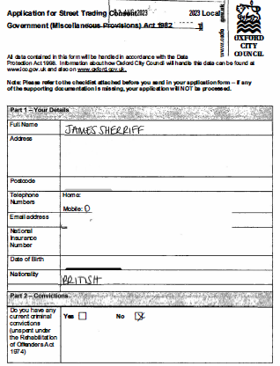
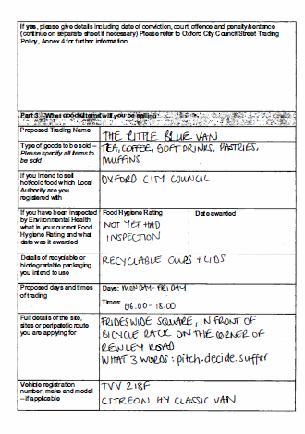
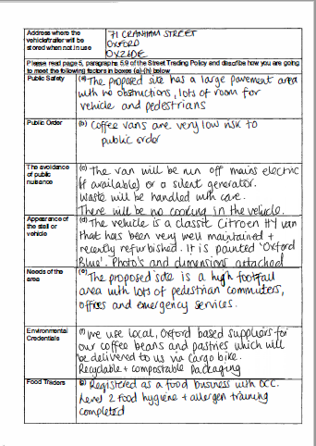

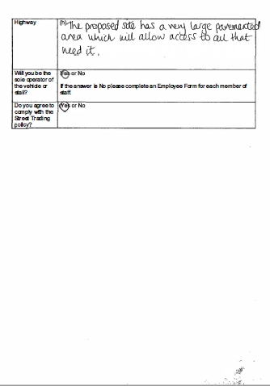

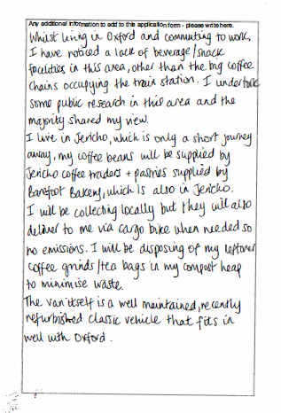

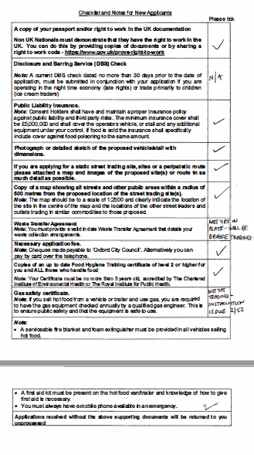

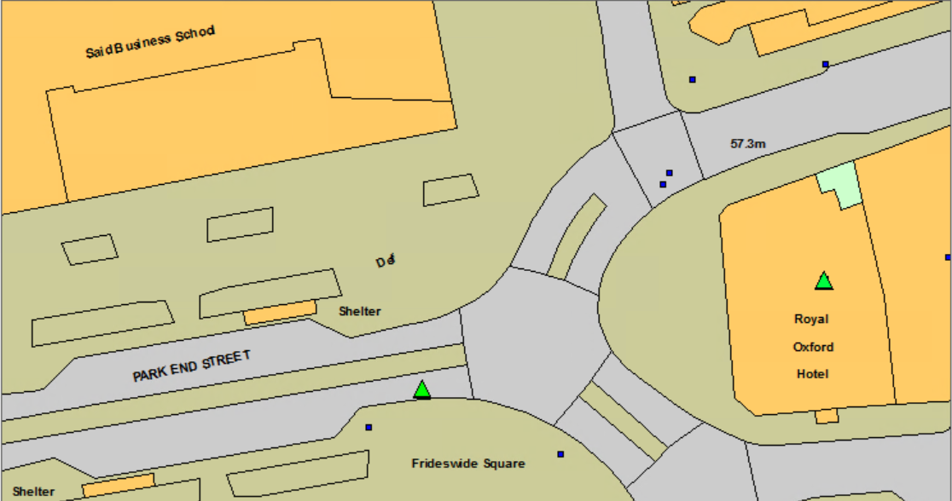

Proposed trading location
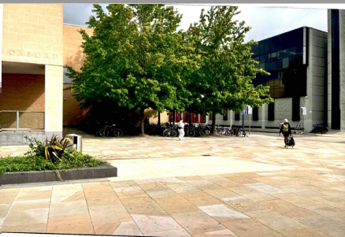

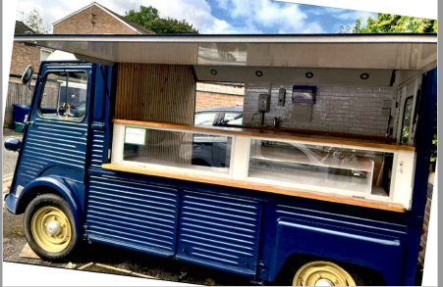
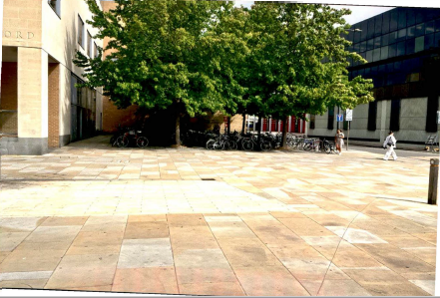

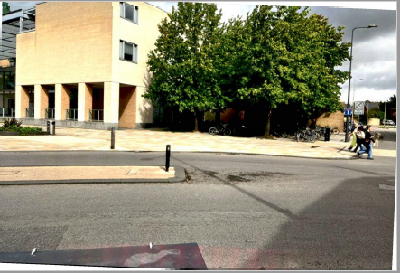

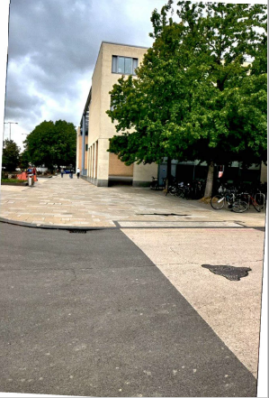

Appendix B

Representation from County Council

I have been to site to look at the location, the public highway adjacent to the crossing point is not appropriate for the following reasons

The footway from Hythe Bridge St to the station has an extremely high footfall and any queuing by customers will cause significant issues and delays particularly for the disabled and partially sighted etc

Oxfordshire County Council therefore cannot support this application and object to the licence being approved

Regards

Steve Walker
Senior Officer
Oxford City
Network Management
Oxfordshire County Council

Appendix C
Representation from Ward Member: Cllr Pressel

I'd love to support this. I'm sure the food and coffee would be delicious and I'm sure it is badly needed, but I'm afraid I am not happy with this location, because the two councils have tried hard to remove clutter from Frideswide Square. This has been controversial, for instance there are not even any traffic signals to help pedestrians cross the road. When people complain to me about the lack of them, as they do regularly, I explain the councils' desire to remove clutter from the space. I realise that the awful road works (and the uncared-for flowerbeds) spoil the effect, but they will be gone next year. I worry that the proposed food van will spoil the effect for years to come, if it gets permission.
I would love them to trade near here, but I hope they can find a better place. Could they try just in front of Beaver House? Or round the corner in the station forecourt, near the statue of the ox?

Kind regards

Susanna

Councillor Susanna Pressel
City Councillor for Osney and St Thomas Ward
County Councillor for Jericho and Osney Division

Appendix D
Representation from City Council City Centre Manager

From a place making perspective we would be keen to support this. Frideswide is an important entry point for many of our visitors and we are keen to add vibrancy and vitality to that area.

As there are large swathes of space, we would be keen for County to reconsider this in 2024,

with thanks
Di

Diana Fawcett MSc (Dist)
Fellow of Institute of Place Management

Oxford City Centre Manager
Regeneration & Economy Service

Oxford City Council, Town Hall, St Aldates, Oxford. OX1 1BX

